|  |
| --- |
| C:\Users\Tsubaki Yukino\Desktop\FlyAwayPlus Project\Capture.JPG |
| **FPT UNIVERSITY** |
| **Installation Guide**  **IVOLUNTEER** |
|  |
| |  |  | | --- | --- | | **Supervisor** | Lecturer Bùi Đình Chiến | | **Group members** | SE03053 - Nguyễn Minh Đức  SE03343 - Nguyễn Thạc Sơn  SE03162 - Võ Tôn Phúc  SE03292 - Phạm Văn Trọng  SE02495 - Nguyễn Văn Tâm | | **Capstone project code** | IVSN | |
|  |

Hanoi, 20/08/2016

**RECORD OF CHANGE**

*A-Added; M-Modified; D-Deleted

|  |  |  |  |  |
| --- | --- | --- | --- | --- |
| **Effective Date** | **Change Items** | **A*M, D** | **Change Description** | **New Version** |
| 15/08/2016 | Installation guide | A | Add new | 1.0 |
|  |  |  |  |  |
|  |  |  |  |  |

*Table 1: Record of change*

**SIGNATURE PAGE**

|  |  |
| --- | --- |
| ORIGINATOR | Phạm Văn Trọng |
|  |  |
| REVIEWERS | Nguyễn Văn Tâm |
|  |  |
| APPROVAL | Bùi Đình Chiến |
|  | *Supervisor* |
|  |  |

Table of Contents

**1.** **INTRODUCTION** 5

1.1. Purpose 5

1.2. Environment 5

**2.** **Application Installation** 5

2.1. Set up Environments on VPS 5

2.1.1. Set up MongoDB on VPS 5

2.1.2. Set up Mongochef on VPS 12

2.1.3. Set up SQL Server 2014 on VPS 17

2.2. Upload source code to host 21

2.2.1. Create domain ivolunteervn.com 21

2.2.2. Upload source code to host 23

# **INTRODUCTION**

## Purpose

This document contains guide-lines step by step to upload source code to host.

## Environment

Following are the software required to upload source code to host:

1. VPS: Window Server 2008 R2 Standard. Service Pack 1.

* VPS information:

**IP**: 125.212.221.177

**RDP port**: 3389

* Plesk control panel information:

**Access Path**: [http://125.212.221.177:8880](http://125.212.221.177:8880/)

# **Application Installation**

## Set up Environments on VPS

## Set up MongoDB on VPS

Connect to VPS by remote desktop.

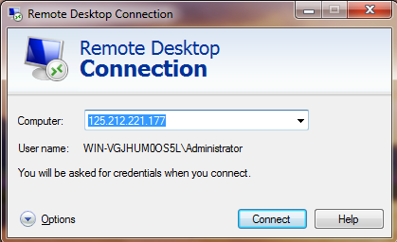

On the VPS, Download MongoDB for window server R2 at: <https://www.mongodb.com/download-center#community>

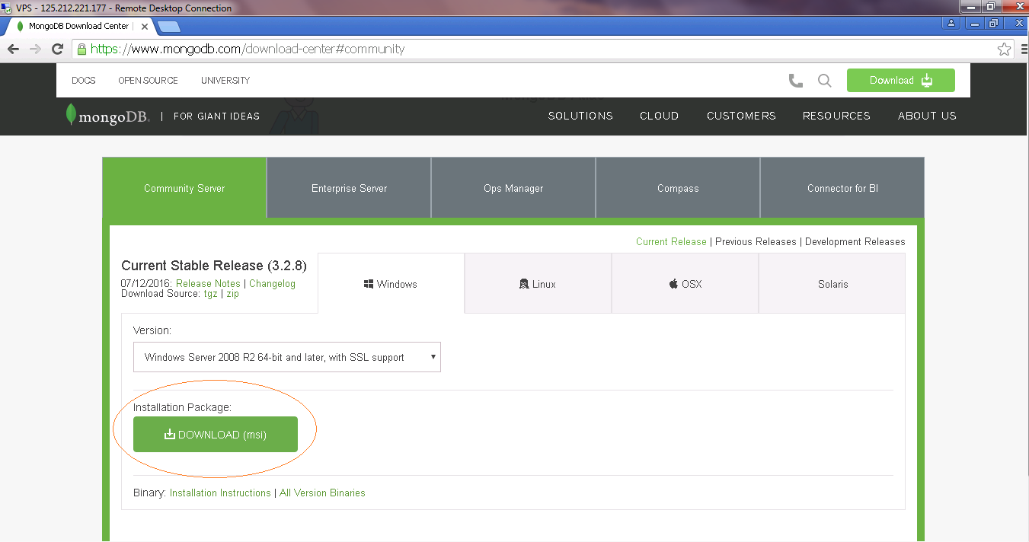

**Step 1**: Run setup file.

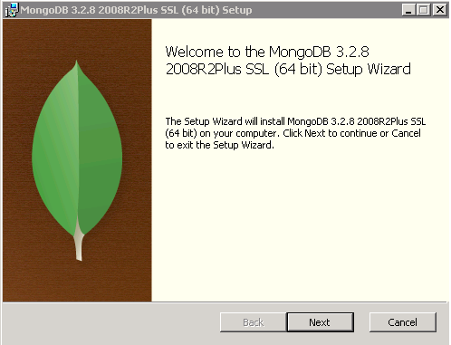

**Step 2**:

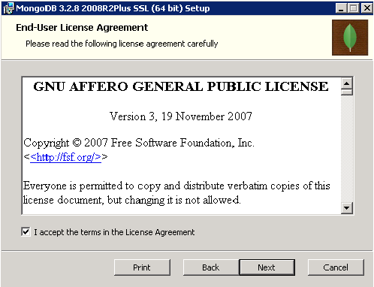

**Step 3:**

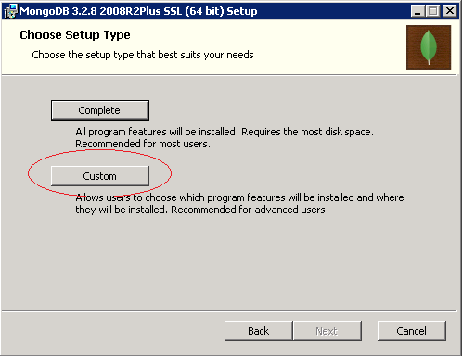

**Step 4:**

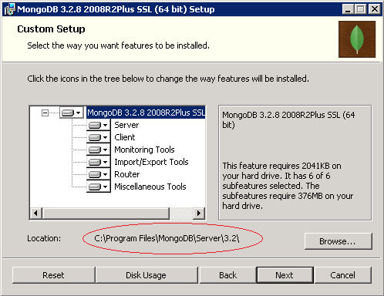

**Step 5:**

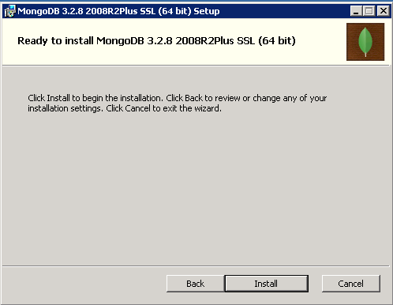

**Step 6:**

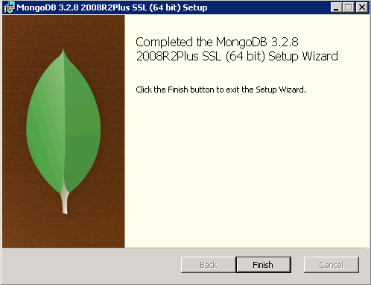

**Step 7**: Configure MongoDB

1. Create folder : C:\MongoStore
2. Then create two subfolders:
   * data
   * log
3. And a configuration file: **config.txt**

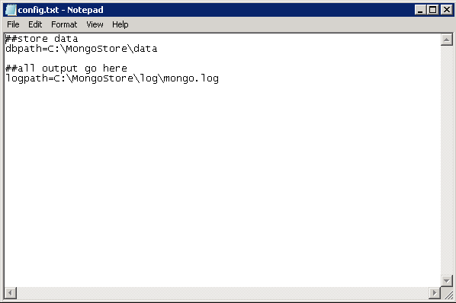

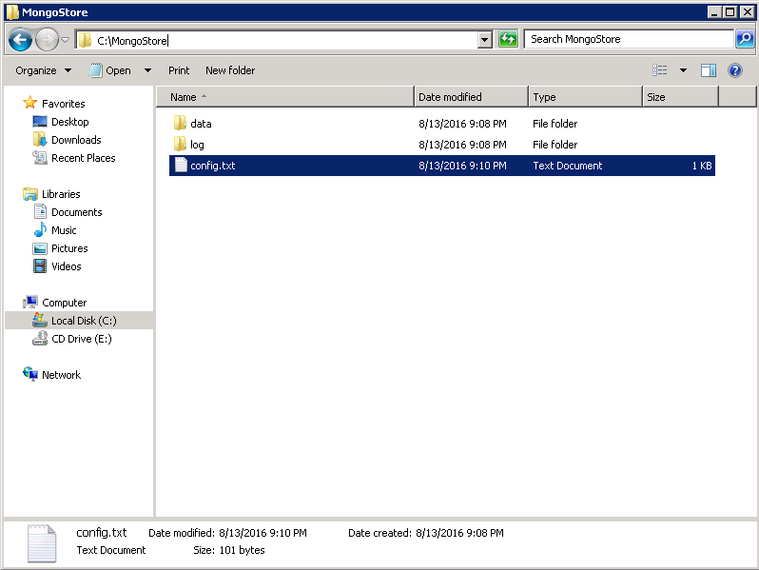

Start CMD and type the command cd to the “bin” folder of MongoDB.

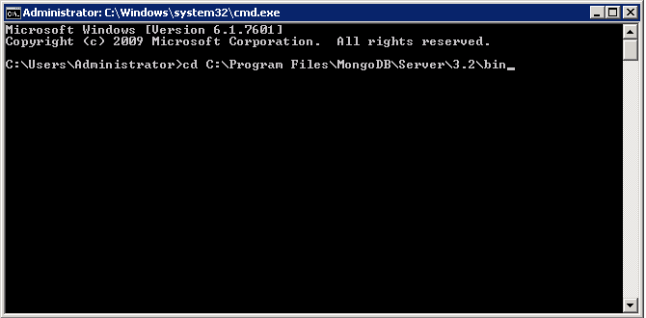

Running MongoDB configuration file:

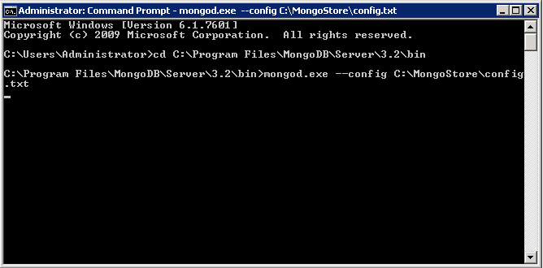

**Step 8**: Copy the file “data” of MongoDB to VPS.

**Step 9**: Setup MongoDB so it can run as Windows service:

Opening command prompt as administrator:

C:\Program Files\MongoDB\Server\3.2\bin>mongod --dbpath=C:\MongoStore\data --logpath=C:\MongoStore\config.txt –install

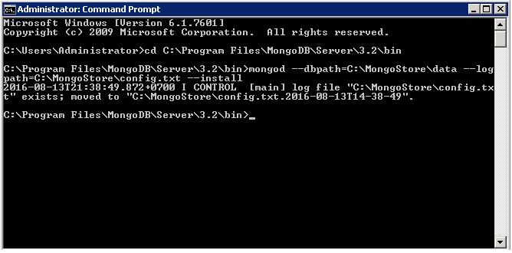

**Step 10**: Start MongoDB.

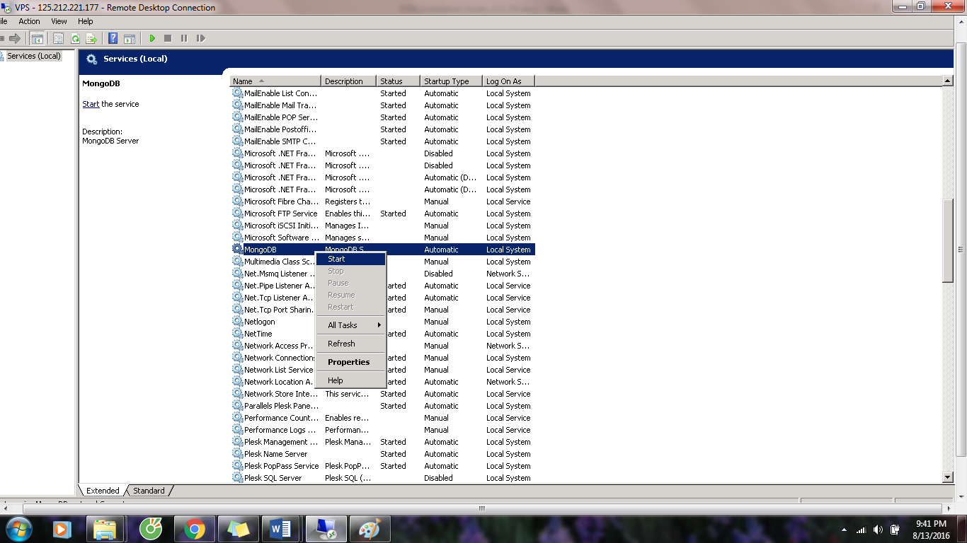

## Set up Mongochef on VPS

Download Mongochef at <http://3t.io/mongochef/download/core/platform/>

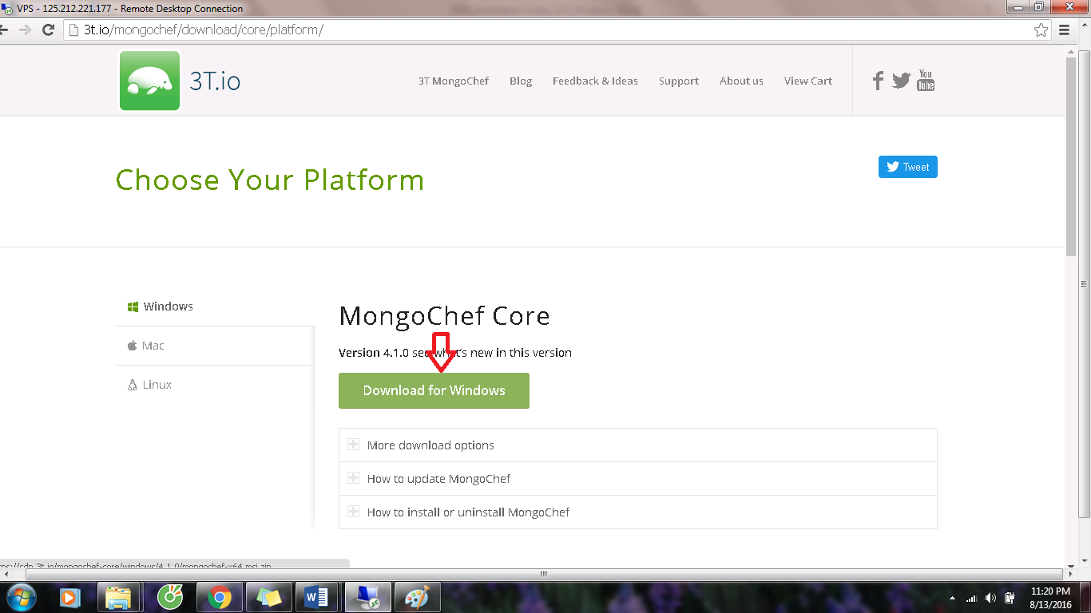

**Step 1:** Run setup file:

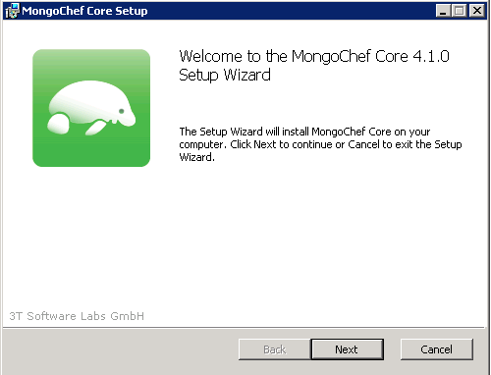

**Step 2**:

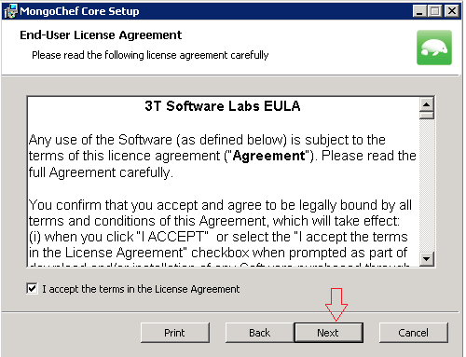

**Step 4**:

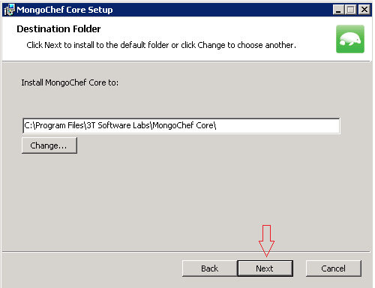

**Step 5**:

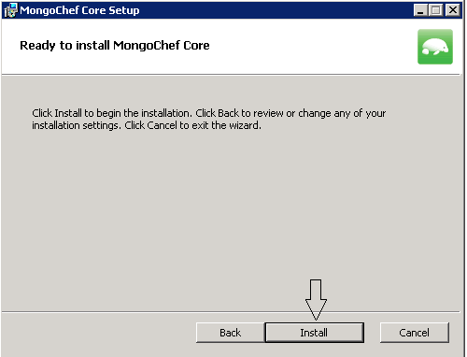

**Step 6**:

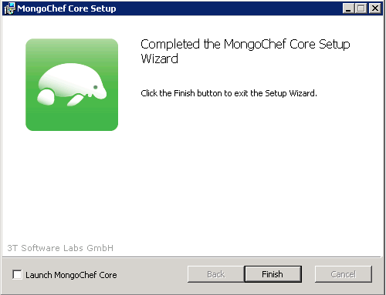

**Step 7**: Run MongoChef

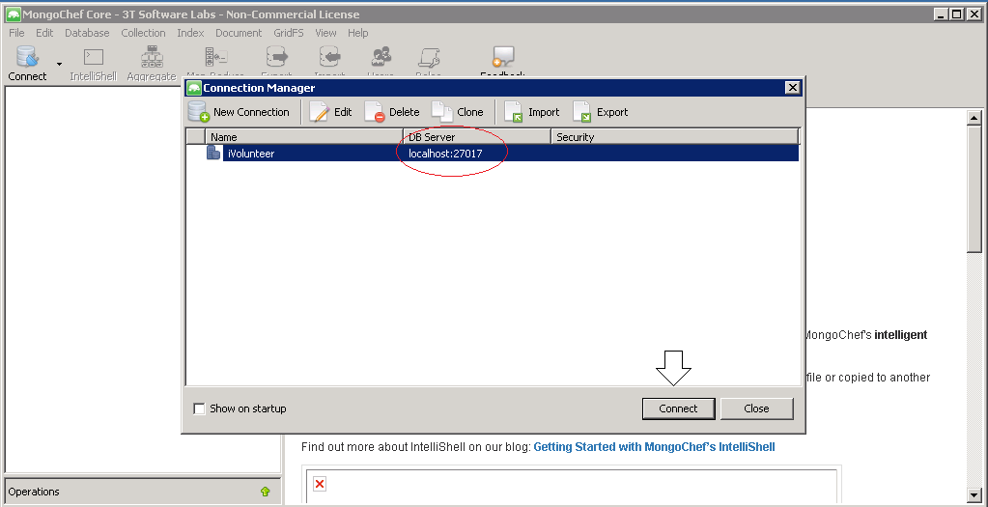

After “Connect” button is clicked, this window should be displayed.

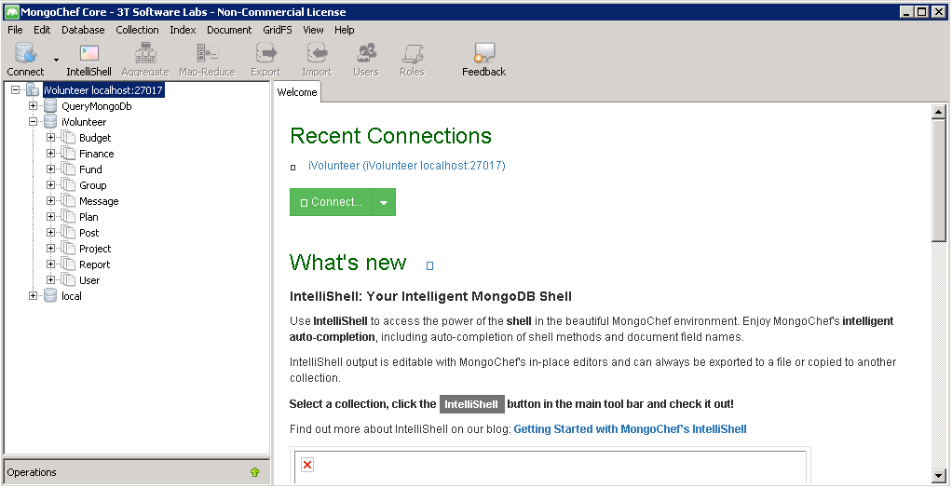

## Set up SQL Server 2014 on VPS

On the VPS, Download SQL Server 2014 at: <https://www.microsoft.com/en-us/download/details.aspx?id=42299>

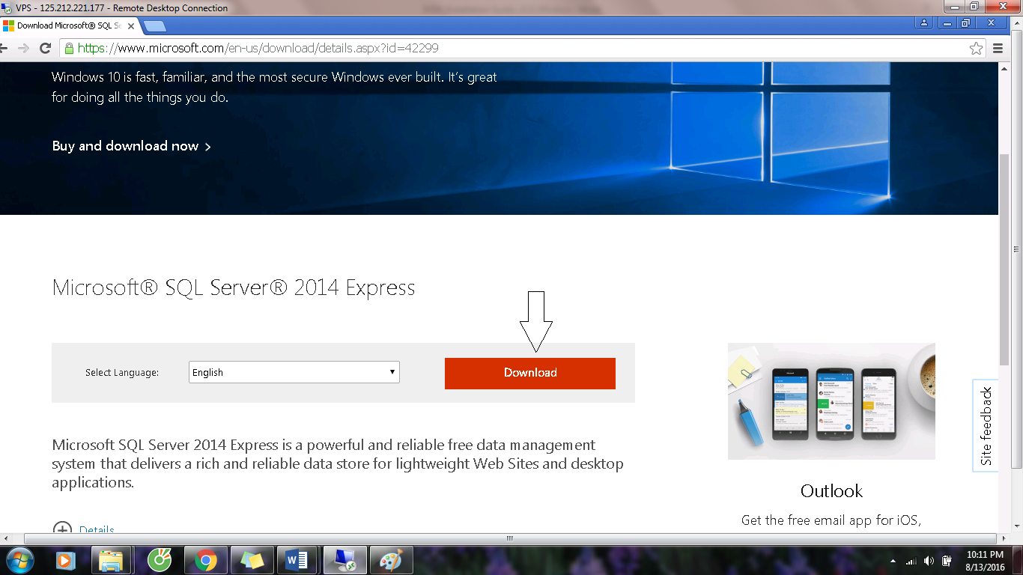

After “Download” button is clicked, this window should be displayed.

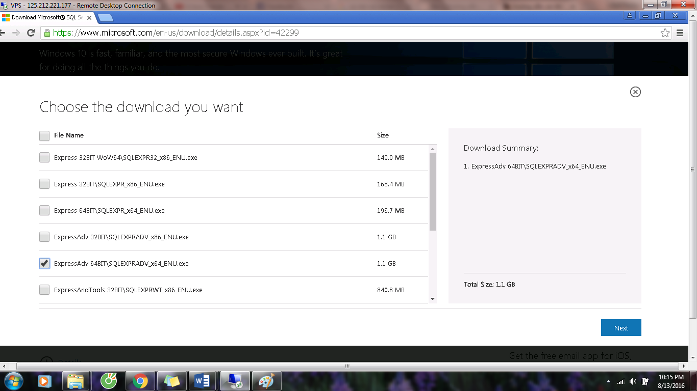

**After installation completed SQL Server 2014**

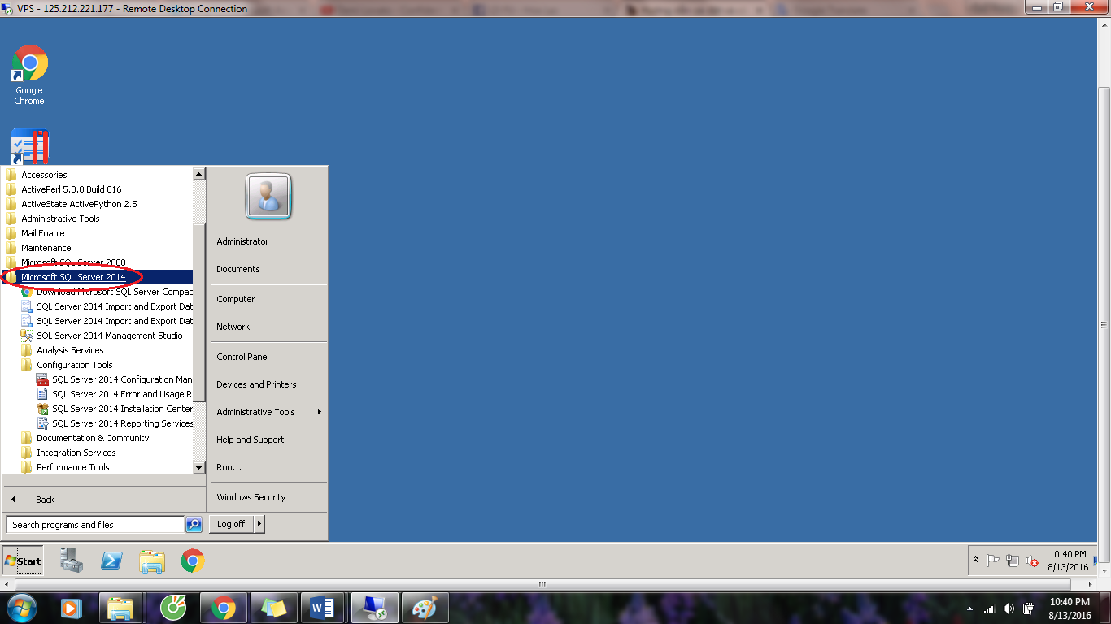

**Start SQL Server.**

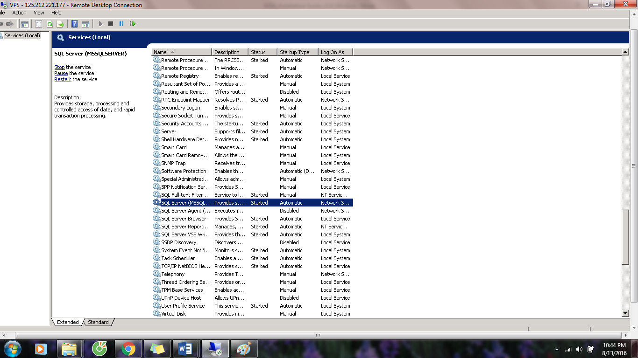

**Step 1**: Copy file DB.sql to VPS

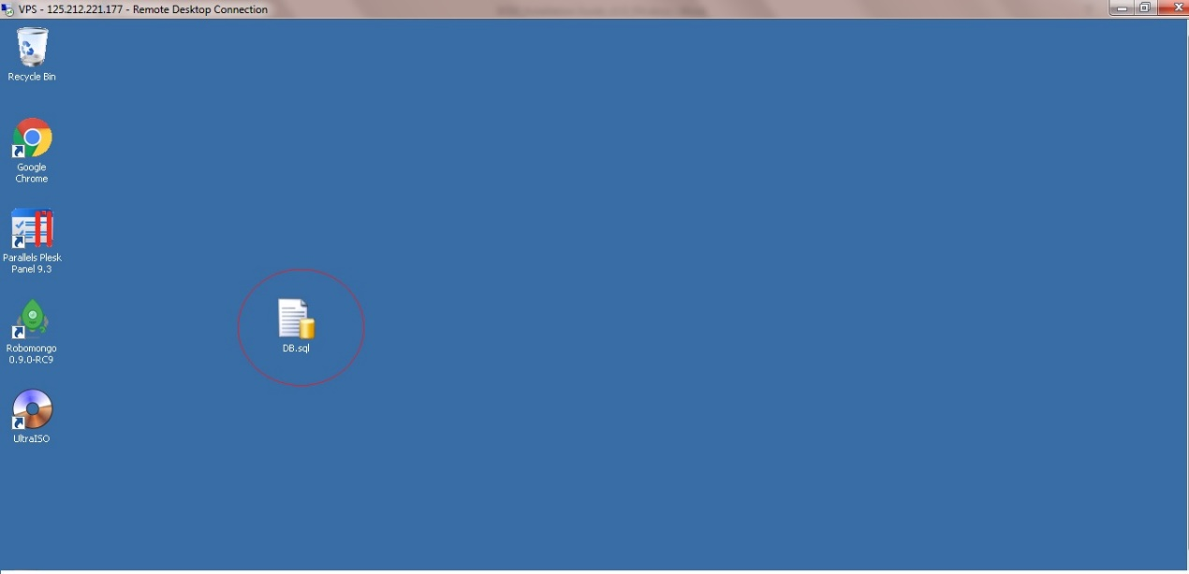

**Step 2**: Open SQL server 2014

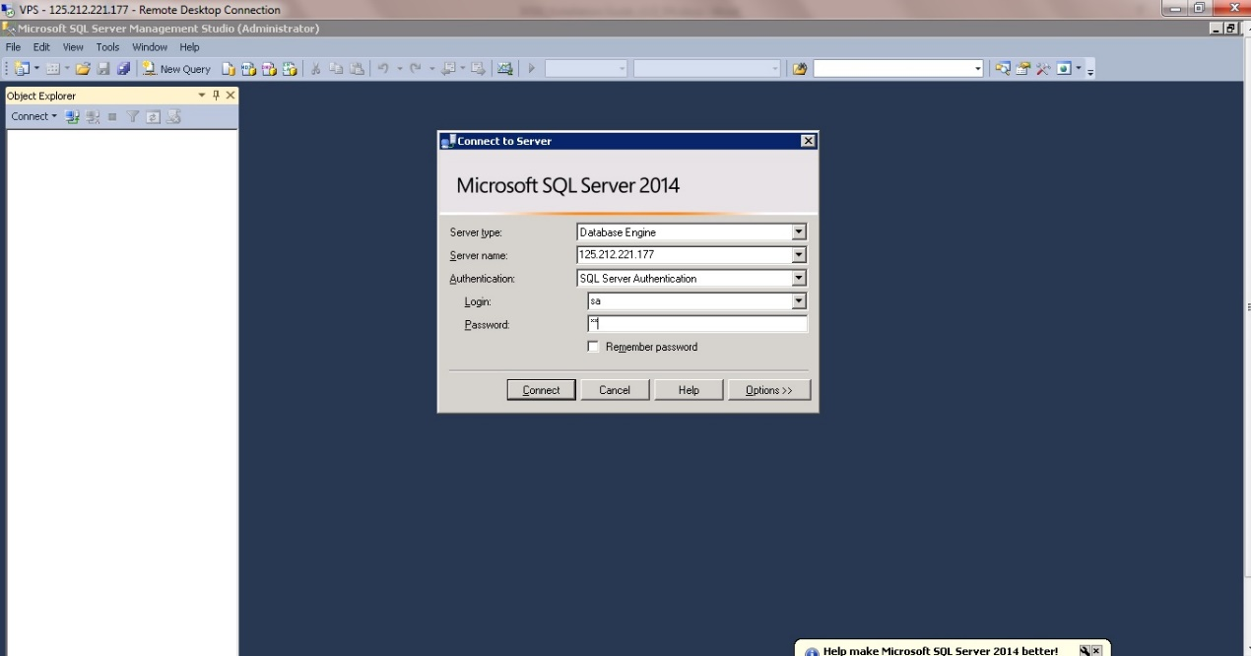

**Step 3**: Create database with name: **iVolunteer**

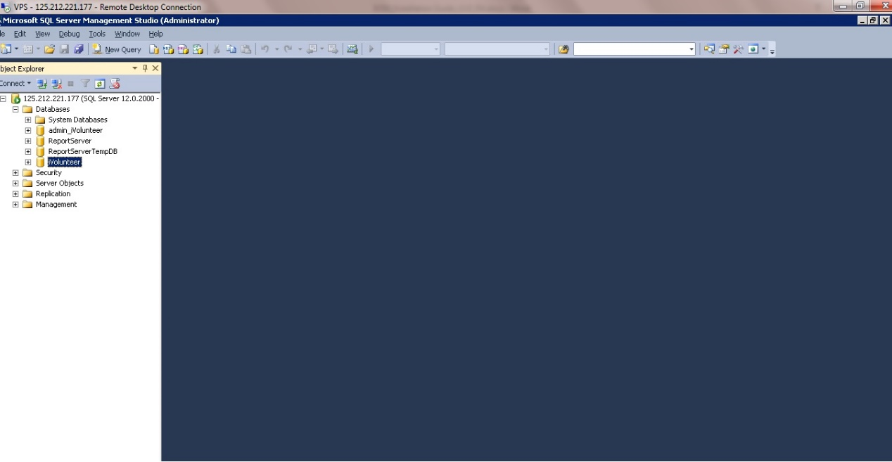

**Step 4**: Run file DB.sql

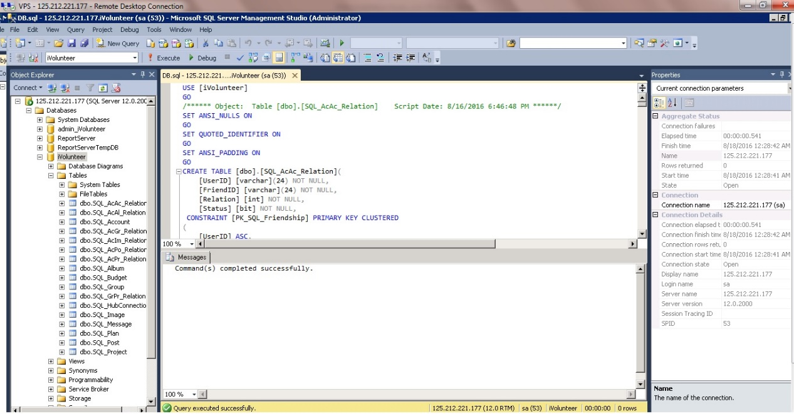

## Upload source code to host

## Create domain ivolunteervn.com

**Step 1:** Login to Plesk panel at: [http://125.212.221.177:8880](http://125.212.221.177:8880/)

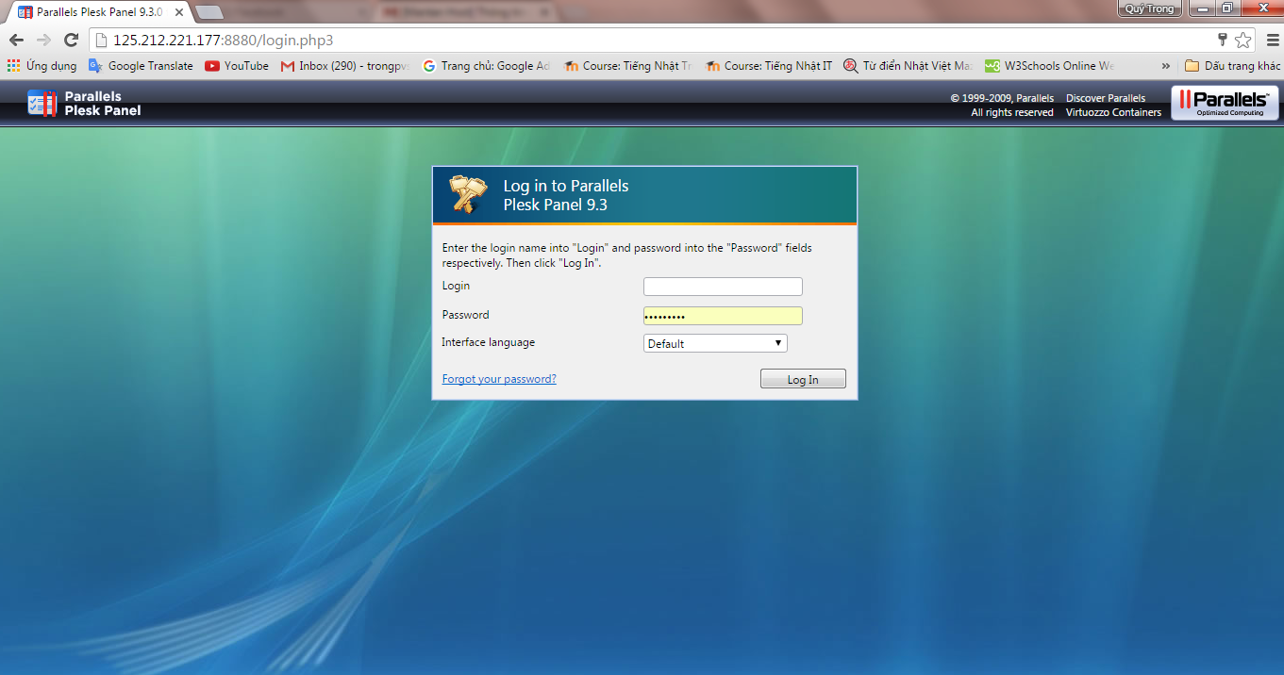

**Step 2:** Create Domain **ivolunteervn.com**

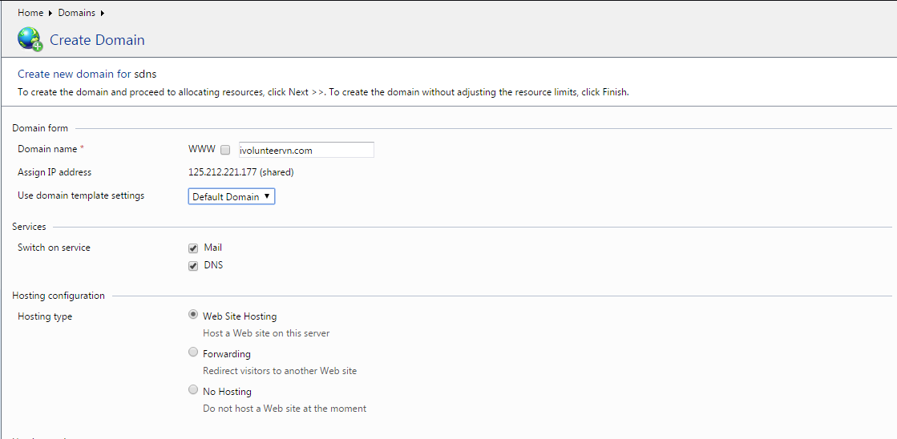

**Step 3:** Click on **ivolunteervn.com**

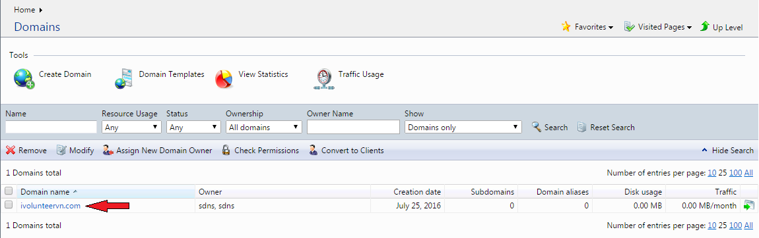

**Step 4:** View **httpdocs** folder in File Manager.

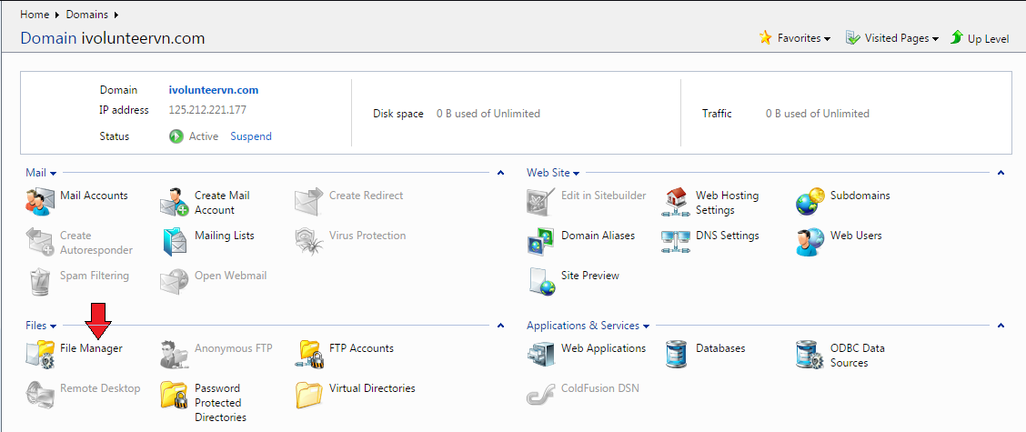

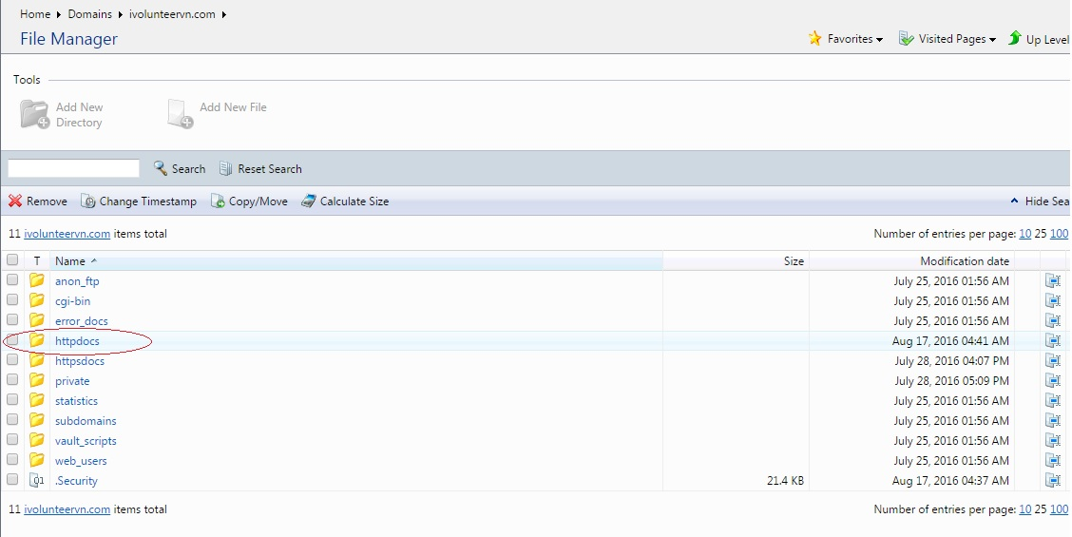

## Upload source code to host

**Step 1:** Publish Website

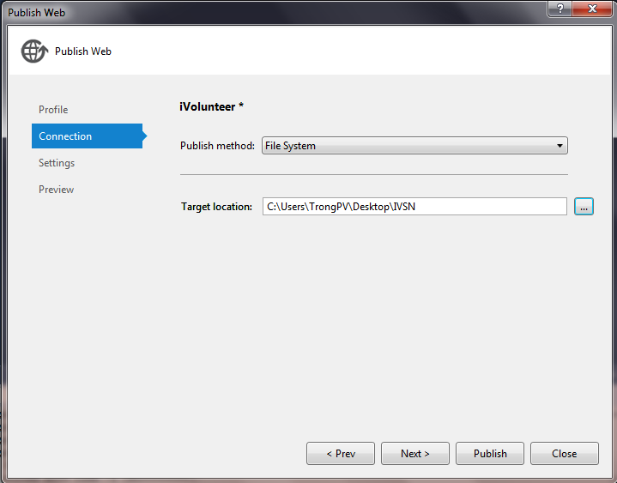

After publishing.

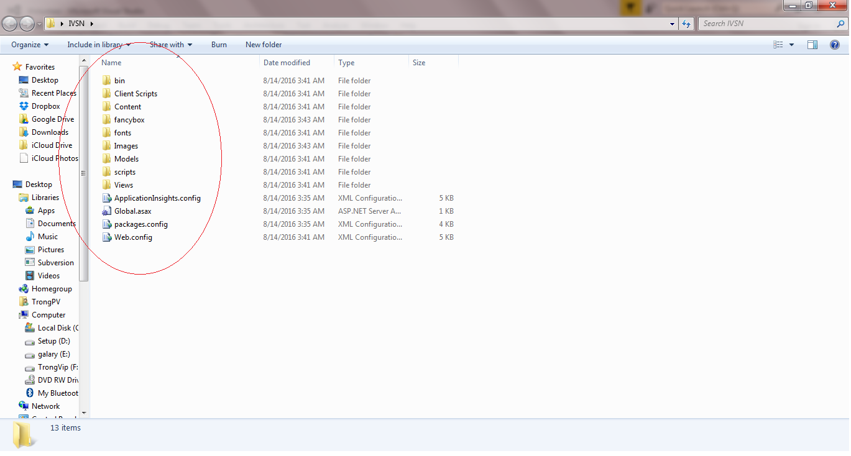

**Step 2:** Upload source code by Filezilla to Host.

1. Open **Filezilla**

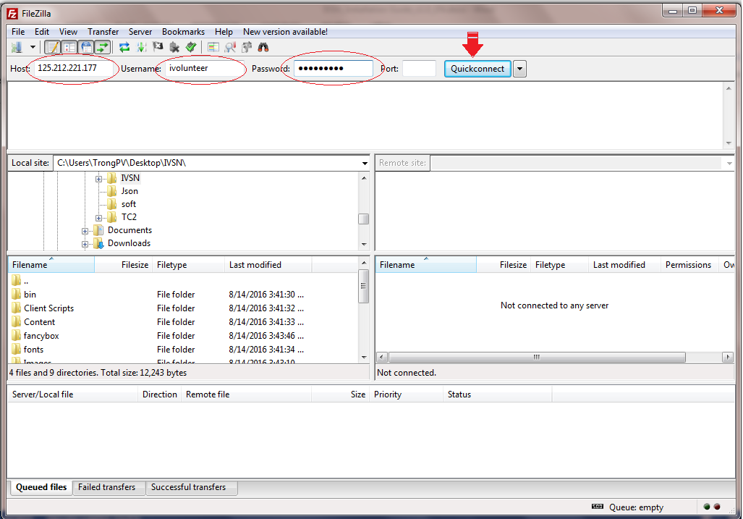

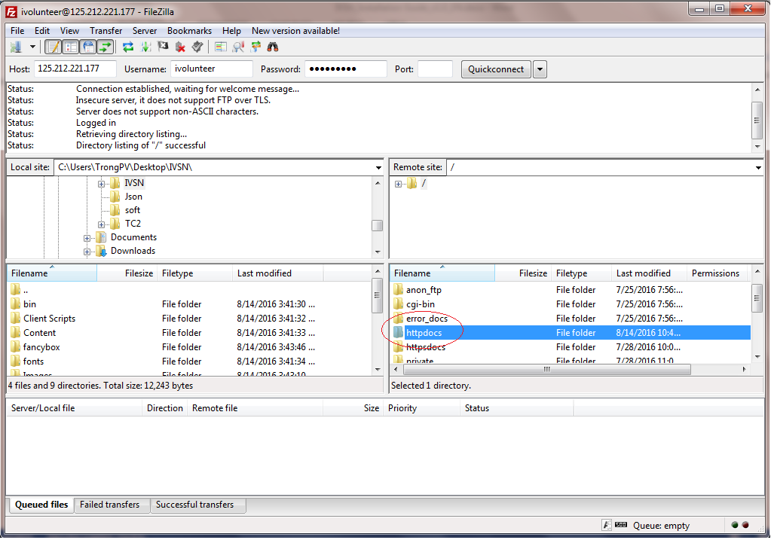

1. Upload the files in the “IVSN” folder has been published to the “httpdocs” folder.

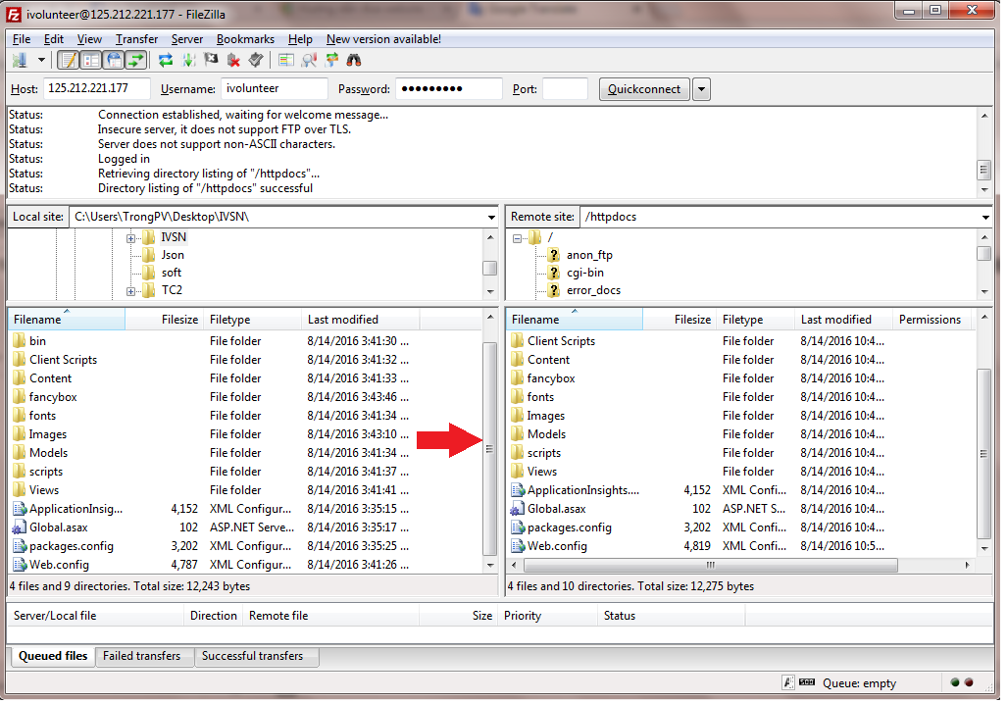

**Step 3:** Change the configuration: Web.config

1. data source = 125.212.221.177
2. user id = sa
3. password = sa

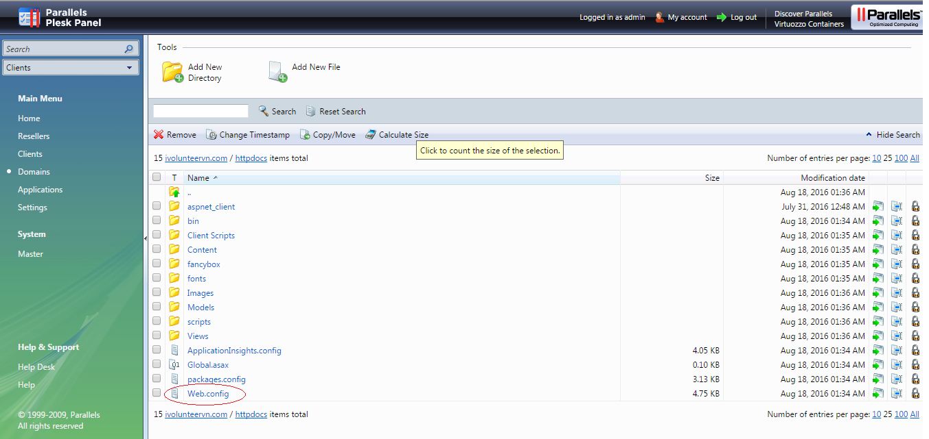

**Step 4:** Pointing “ivolunteervn.com” domain to **125.212.221.177**

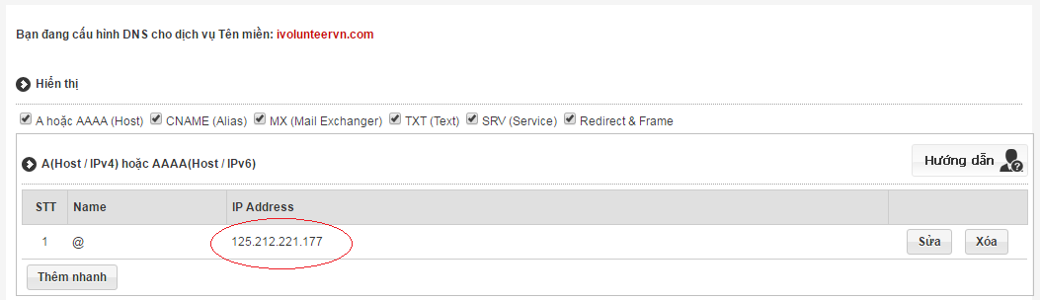

**Step 5:** Open Browser and go to link: **ivolunteervn.com**

